Practical 2

Aim: Design Phone structure using Builder Design Pattern.

Description:
The Builder design pattern is a creational pattern used to construct complex objects step by step. It separates the construction of a complex object from its representation, allowing the same construction process to create different representations. This pattern is particularly useful when dealing with objects that have numerous optional parameters or configurations.

Code:

1. PhoneClient.java

// Client
import java.util.Scanner;

public class PhoneClient {
public static void main(String[] args) {
Scanner scanner = new Scanner(System.in);

// Gathering user input for phone details
System.out.println("Enter the phone details:");

System.out.print("OS: ");
String os = scanner.nextLine();

System.out.print("RAM (in GB): ");
int ram = scanner.nextInt();

scanner.nextLine(); // Consume the newline character

System.out.print("Processor: ");
String processor = scanner.nextLine();

System.out.print("Screen Size (in inches): ");
double screenSize = scanner.nextDouble();

System.out.print("Battery (in mAh): ");
int battery = scanner.nextInt();

// Creating a phone using the builder with user input
Phone phone = new Phone.PhoneBuilder()
.setOs(os)
.setRam(ram)
.setProcessor(processor)
.setScreenSize(screenSize)
.setBattery(battery)
.build();

// Displaying phone details
System.out.println("\nPhone Details:");
System.out.println("OS: " + phone.getOs());
System.out.println("RAM: " + phone.getRam() + "GB");
System.out.println("Processor: " + phone.getProcessor());
System.out.println("Screen Size: " + phone.getScreenSize() + " inches");
System.out.println("Battery: " + phone.getBattery() + " mAh");

// Close the scanner
scanner.close();
}
}

2. Phone.java

// Product
class Phone {
private String os;
private int ram;
private String processor;
private double screenSize;
private int battery;

// Constructor is private to enforce the use of the builder
private Phone() {}

// Getters for Phone attributes
public String getOs() {
return os;
}

public int getRam() {
return ram;
}

public String getProcessor() {
return processor;
}

public double getScreenSize() {
return screenSize;
}

public int getBattery() {
return battery;
}

// Builder
static class PhoneBuilder {
private Phone phone = new Phone();

public PhoneBuilder setOs(String os) {
phone.os = os;
return this;
}

public PhoneBuilder setRam(int ram) {
phone.ram = ram;
return this;
}

public PhoneBuilder setProcessor(String processor) {
phone.processor = processor;
return this;
}

public PhoneBuilder setScreenSize(double screenSize) {
phone.screenSize = screenSize;
return this;
}

public PhoneBuilder setBattery(int battery) {
phone.battery = battery;
return this;
}

public Phone build() {
return phone;
}
}
}

Output:
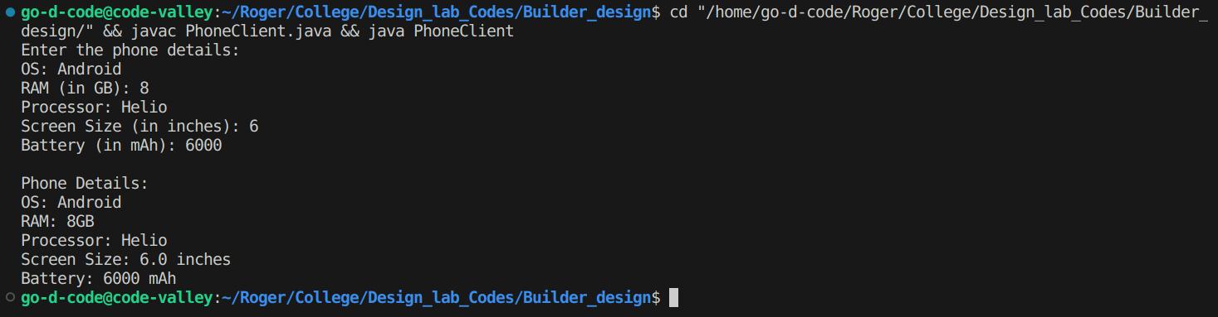
Class Diagram:

Aim: Design Property structure using Builder Design Pattern

Description:
The Builder design pattern is a creational pattern used to construct complex objects step by step. It separates the construction of a complex object from its representation, allowing the same construction process to create different representations. This pattern is particularly useful when dealing with objects that have numerous optional parameters or configurations.

Code:

1. Property.java

import java.util.Scanner;

public class Property {
private String type;
private double price;
private double area;
private int bedrooms;
private int bathrooms;

private Property(PropertyBuilder builder) {
this.type = builder.type;
this.price = builder.price;
this.area = builder.area;
this.bedrooms = builder.bedrooms;
this.bathrooms = builder.bathrooms;
}

public String getType() {
return type;
}

public double getPrice() {
return price;
}

public double getArea() {
return area;
}

public int getBedrooms() {
return bedrooms;
}

public int getBathrooms() {
return bathrooms;
}

public static class PropertyBuilder {
private String type;
private double price;
private double area;
private int bedrooms;
private int bathrooms;

public PropertyBuilder(String type, double price, double area) {
this.type = type;
this.price = price;
this.area = area;
}

public PropertyBuilder bedrooms(int bedrooms) {
this.bedrooms = bedrooms;
return this;
}

public PropertyBuilder bathrooms(int bathrooms) {
this.bathrooms = bathrooms;
return this;
}

public Property build() {
return new Property(this);
}
}

public static void main(String[] args) {
Scanner scanner = new Scanner(System.in);

System.out.println("Enter property type:");
String type = scanner.nextLine();

System.out.println("Enter property price:");
double price = scanner.nextDouble();

System.out.println("Enter property area:");
double area = scanner.nextDouble();

System.out.println("Enter number of bedrooms:");
int bedrooms = scanner.nextInt();

System.out.println("Enter number of bathrooms:");
int bathrooms = scanner.nextInt();

Property property = new Property.PropertyBuilder(type, price, area)
.bedrooms(bedrooms)
.bathrooms(bathrooms)
.build();

System.out.println("\nProperty details:");
System.out.println("Type: " + property.getType());
System.out.println("Price: $" + property.getPrice());
System.out.println("Area: " + property.getArea() + " sq. ft.");
System.out.println("Bedrooms: " + property.getBedrooms());
System.out.println("Bathrooms: " + property.getBathrooms());

scanner.close();
}
}

Output:
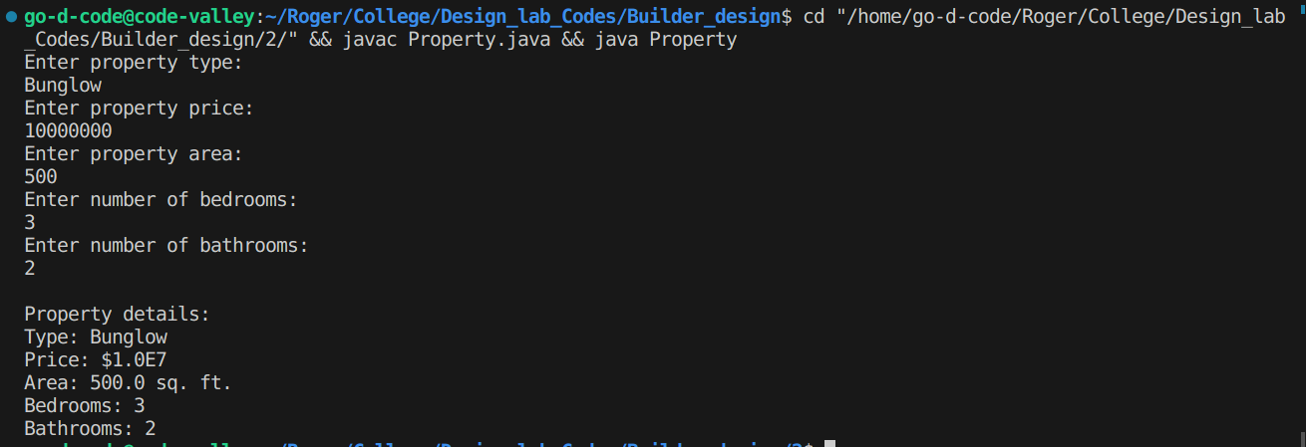
Class Diagram:

